Table of Contents
1)About logging table 2
2)Deleting and inserting a small sample 4
3)Fully reuploading data 5
4)About the functions 7

1)About logging table
Each table contains write_log function. Here is an example with cities. Full codes for the procedures can be found in the attached SQL file.
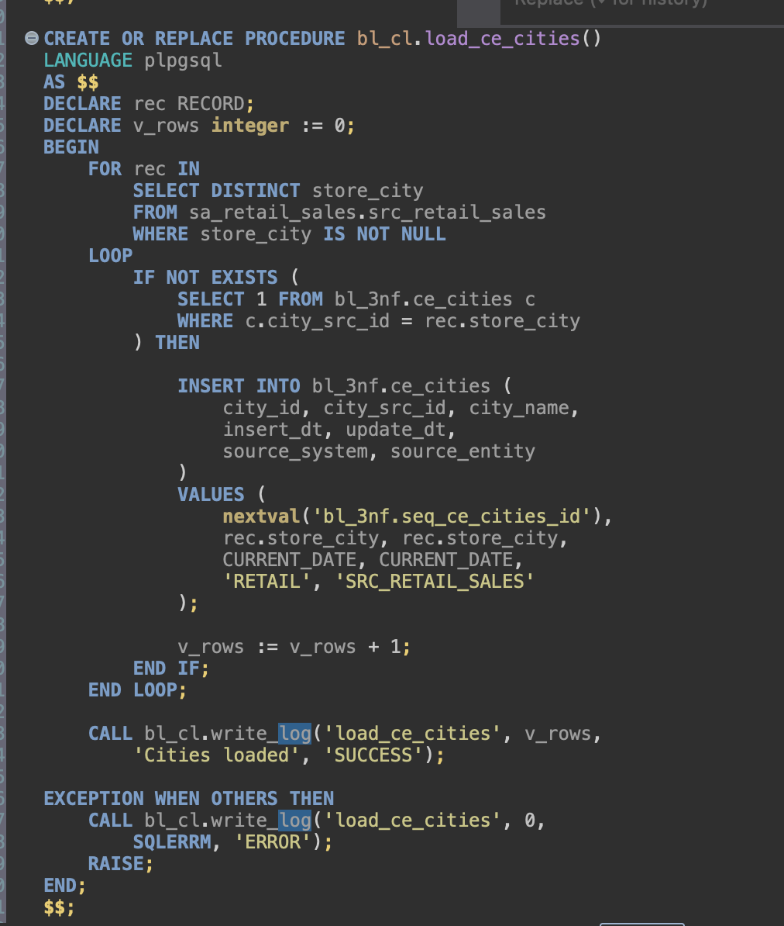
And here is the logging procedure itself alongside logging table creation code.
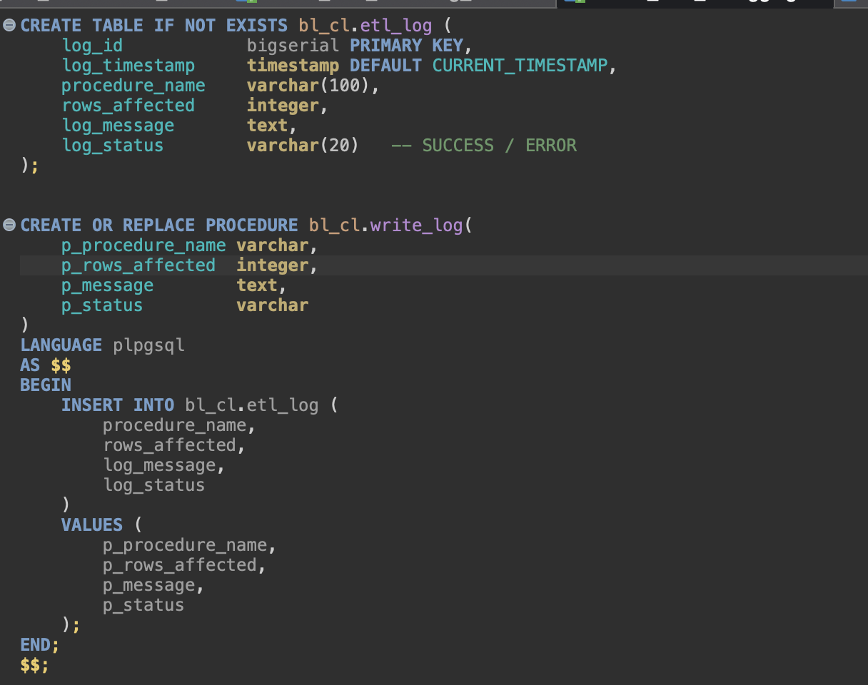
Since the source files are static csvs and the tables have already been loaded during one of the past tasks, we can delete some of the values to see how the procedures behave when there’s actually something to insert and then redo – see what happens when there is nothing to insert.

2)Deleting and inserting a small sample
Deleting 20 sales rows.
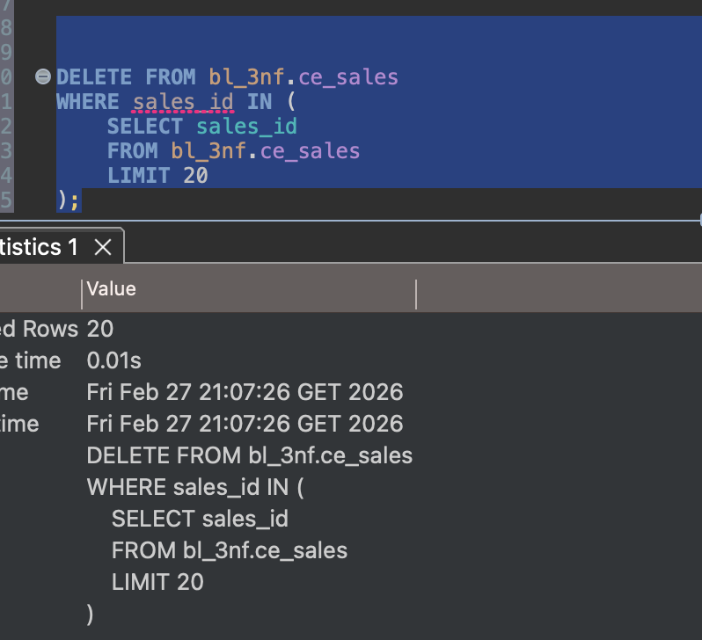
Looking at the two latest procedures. Log_id 22 affected 20 rows – the 20 inserted rows.
The one right after affected 0 rows, as there was nothing left to insert.
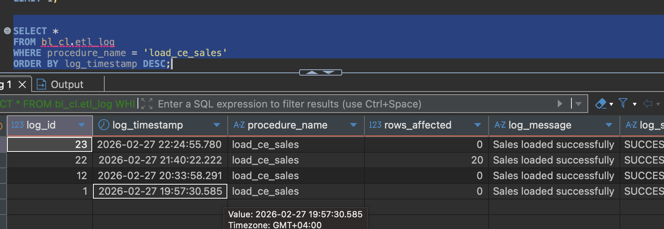

3)Fully reuploading data
Another test – delete and reupload all payments. To do that all sales will have to be deleted first, as all online sales have FK connection to payments.
Here is the starting state – the only row in payments is unknowns which helps with nulls.
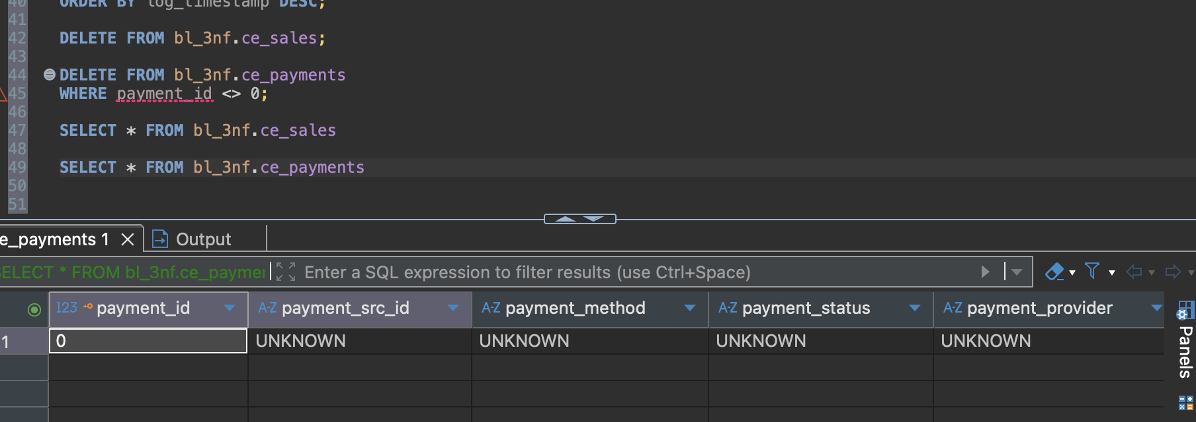
Then we run the payment load procedure.
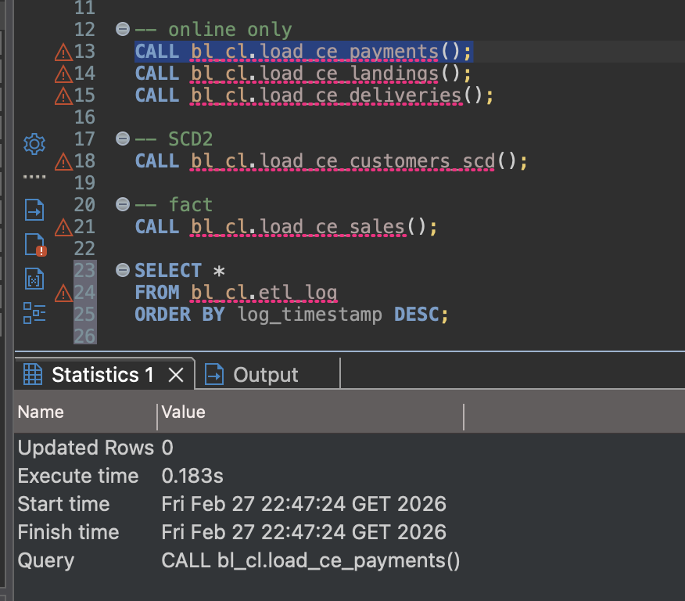
Though it says updated rows 0, by select * from the payment table, we see that it’s properly loaded in.
,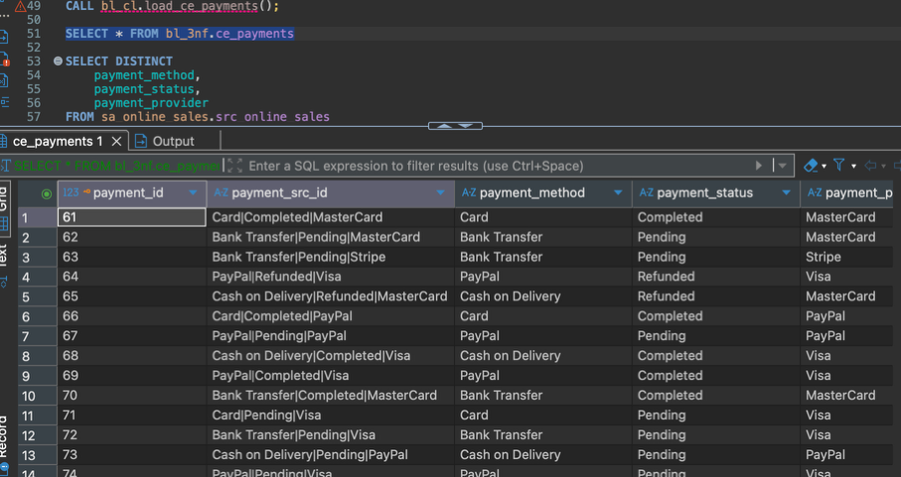
Now, onto sales table again. Running the function once loads the table, running it twice does nothing, as intended.
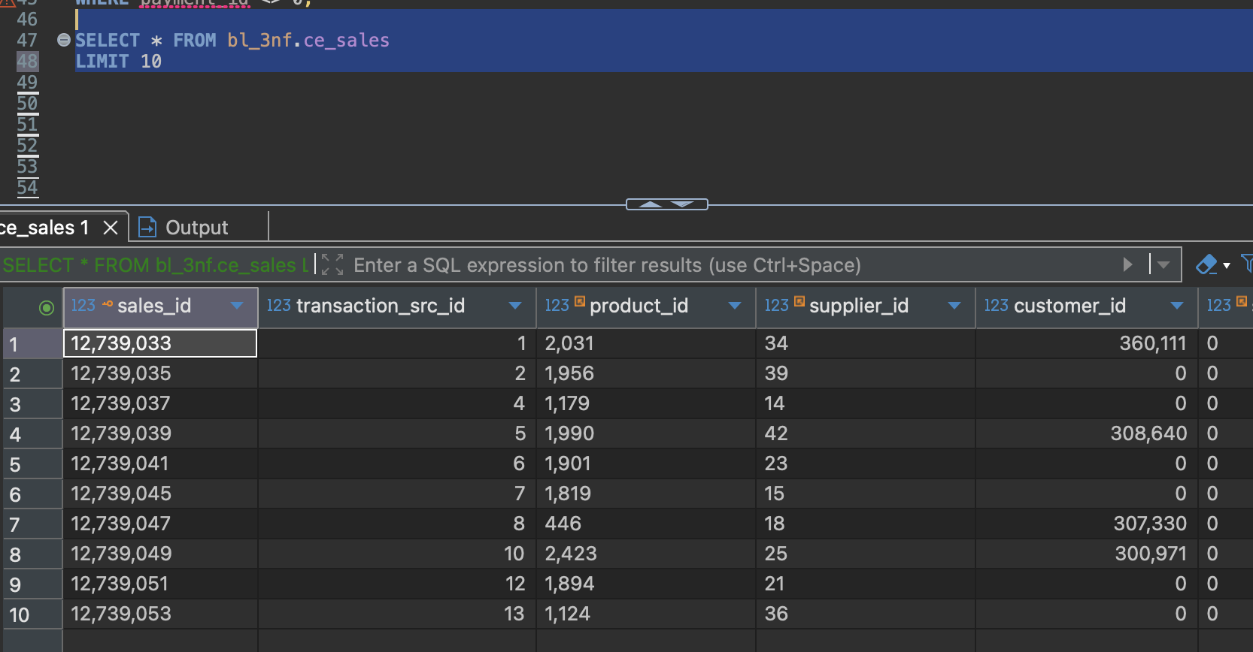
Here is how log table looks after the latest runs of load functions.
❗At the moment, reloading payments and some of the other tables shows ‘rows_affected’ all of them, but it doesn’t seem to cause any other problems.
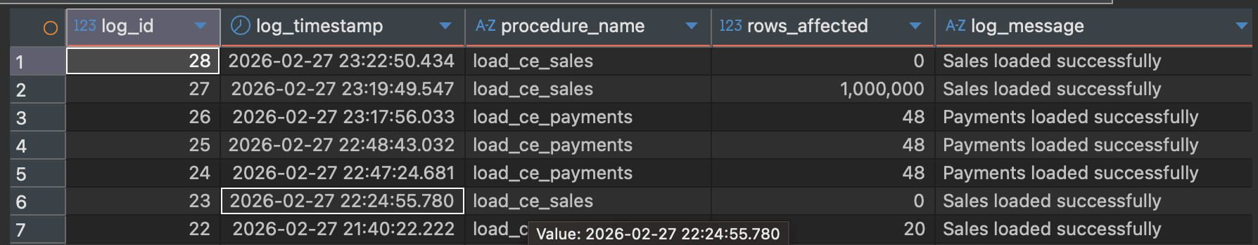

4)About the functions
Now, lets go over the functions – Sales being the most distinct and complex and Employee as an example for the rest.
4.1)Employee
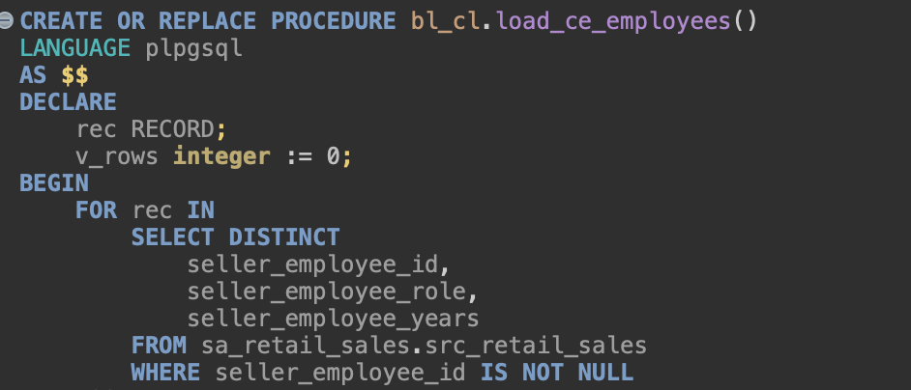
Here we’re looking for unique, existing, not yet fetched employees in the retail source table.
If we find such employees, they’ll be inserted in the corresponding 3NF table.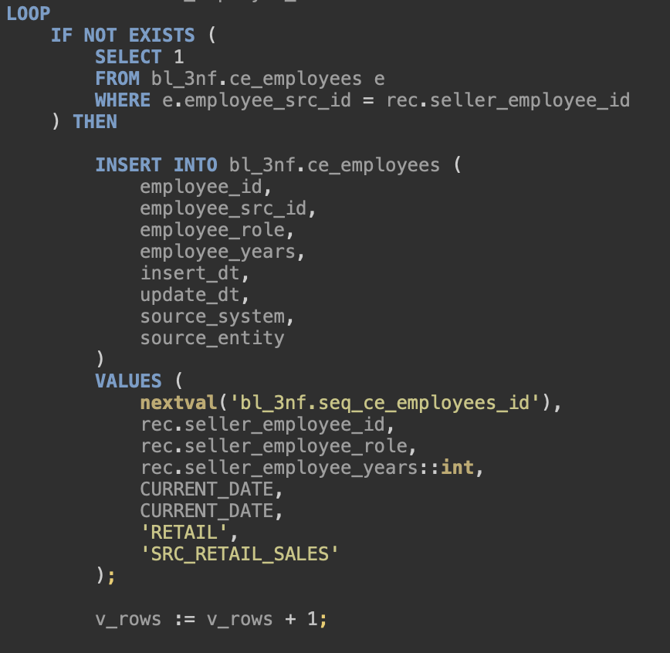

Being SCD type 1, finding an existing row with different values, will result into an updated row.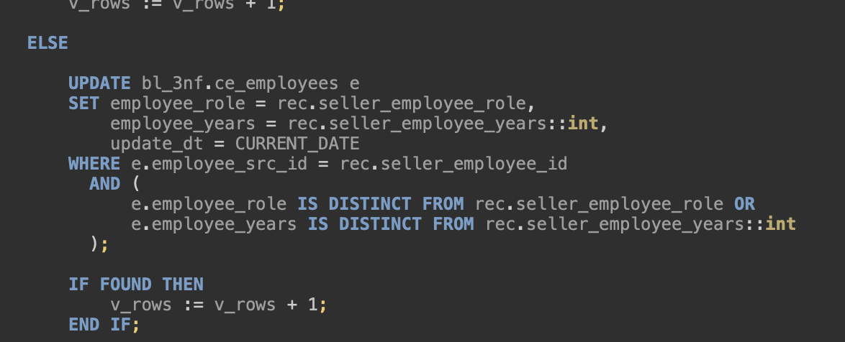
Finally, finished procedure is logged in the corresponding table.
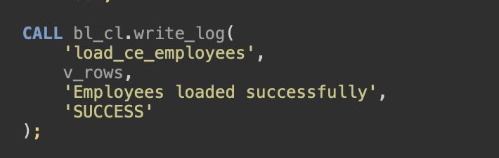

4.2)Sales
Sales load takes in lots of columns from the source tables. For many rows certain data that is exclusive for either of the sources are missing are null and there needs to be a way to deal with it, since there are ‘not null’ constraints in DDL.
Marking them ‘UNKNOWN’ is one way to deal with
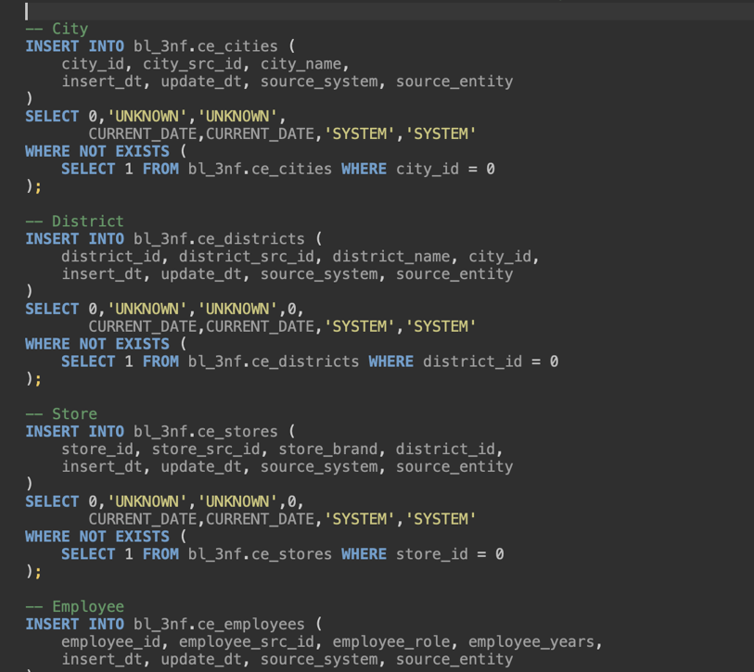

Facts are inserted into Sales table from the both sources with UNION ALL.
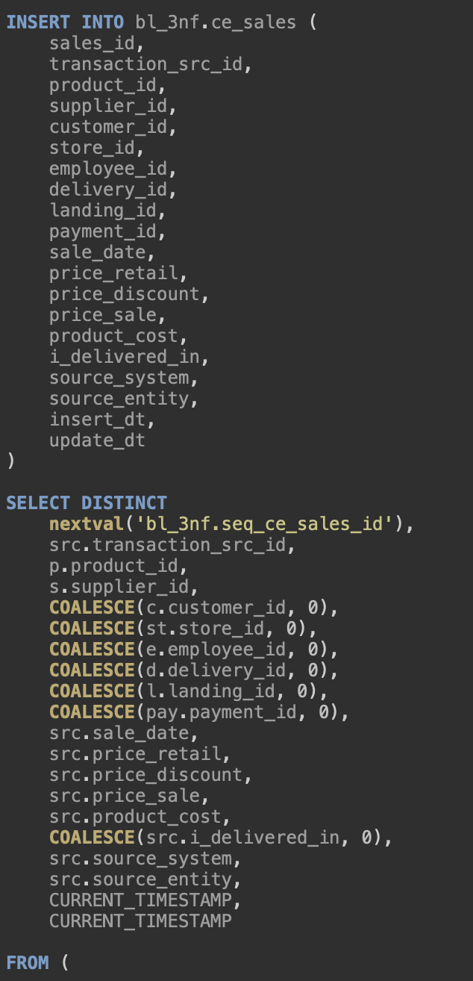
Table contains foreign keys, therefore joins are used.
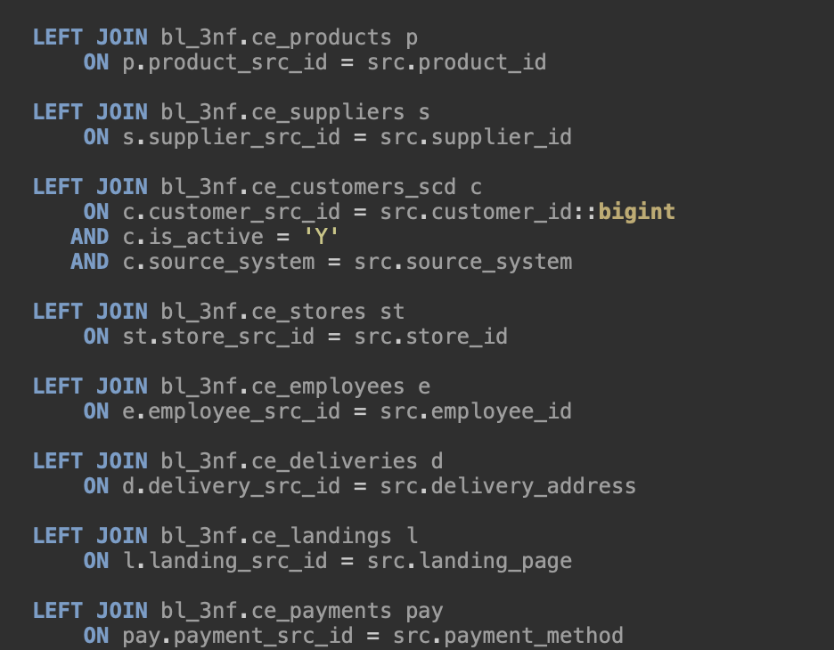
Just like the other tables, transactions are logged.
